Ex1:

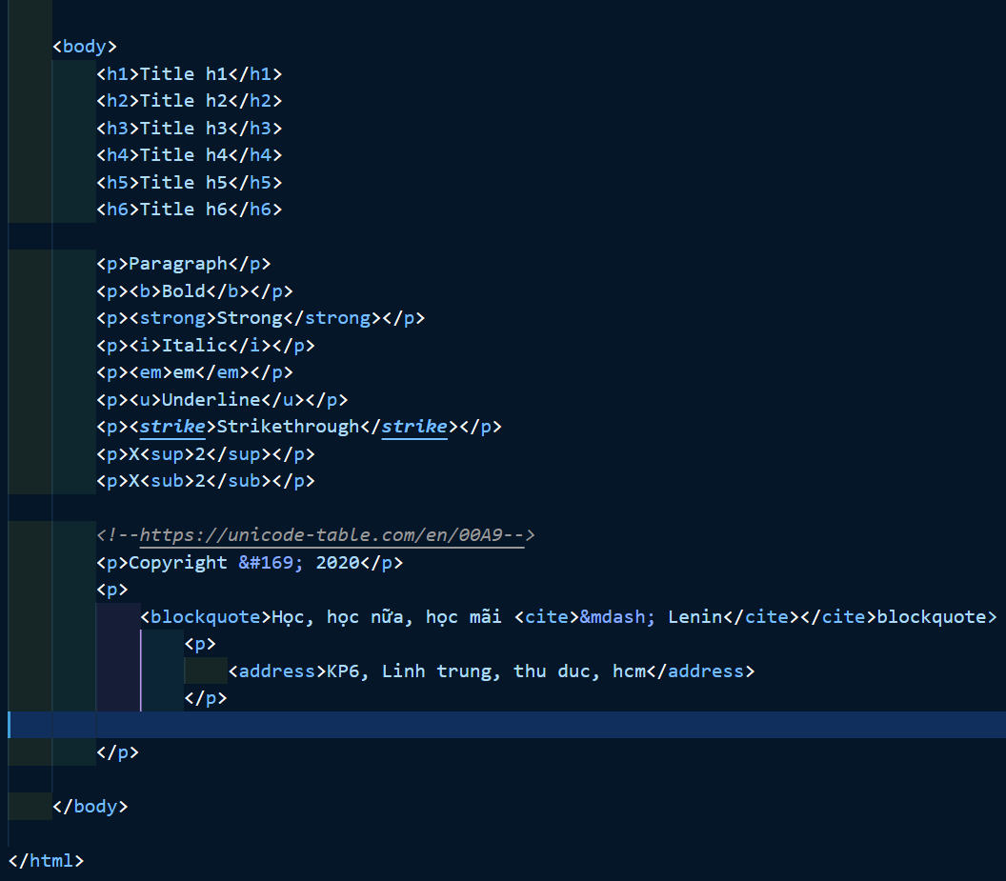

Output:

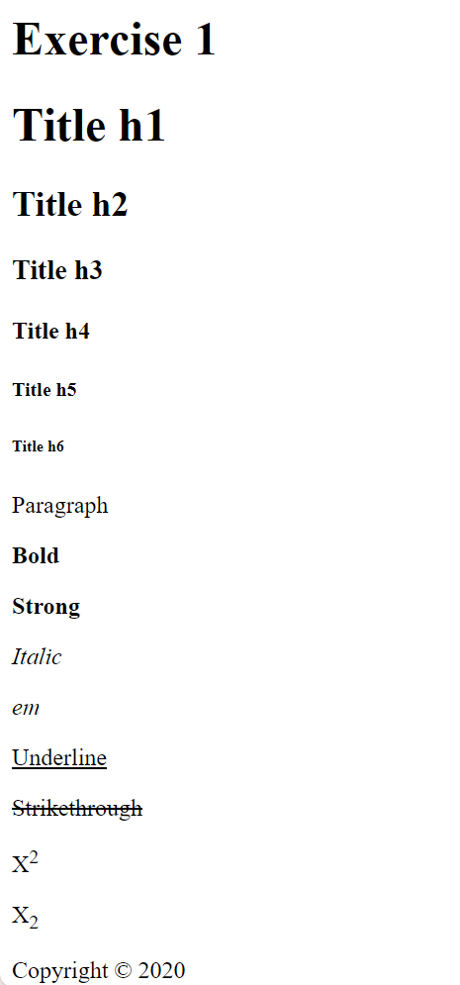

Ex2:

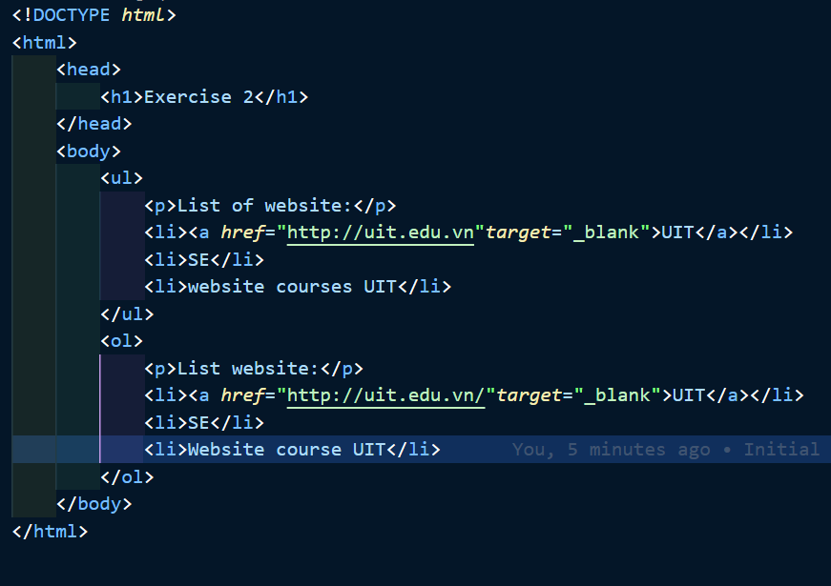

Output:

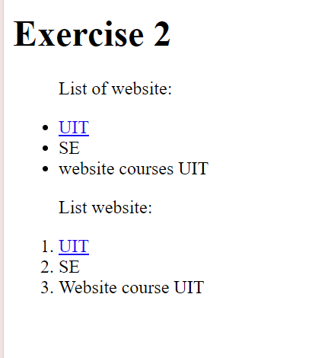

Ex3:

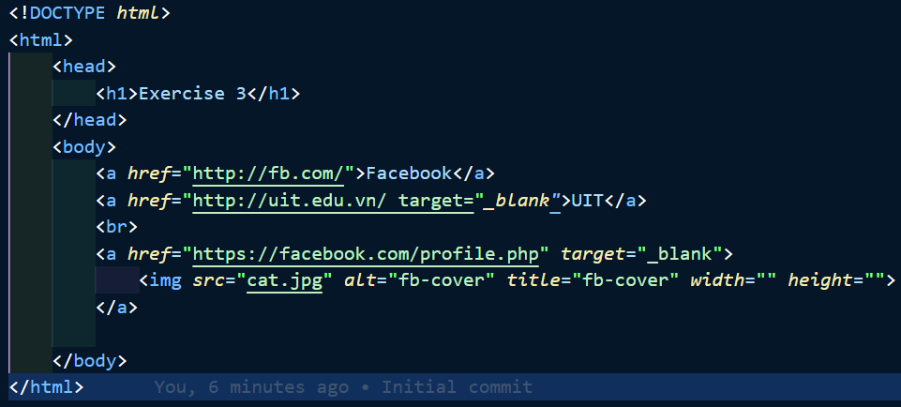

Output:

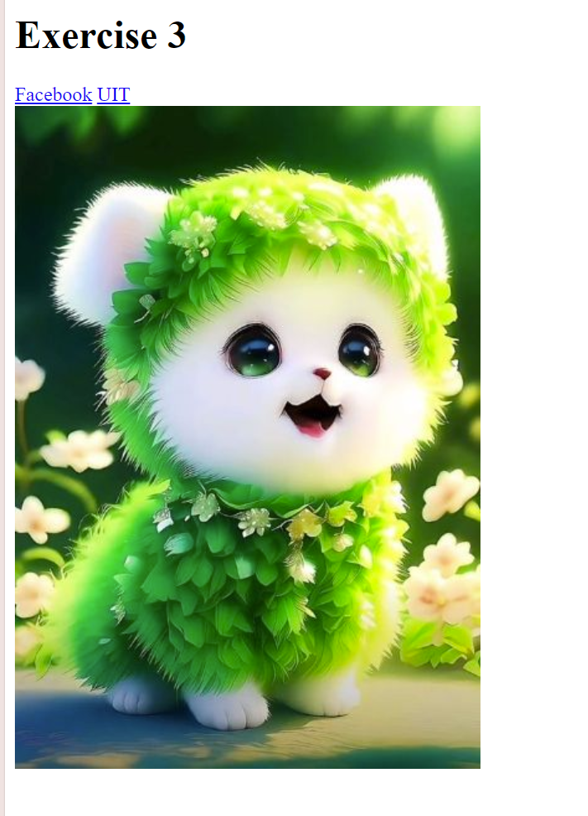

Ex4:

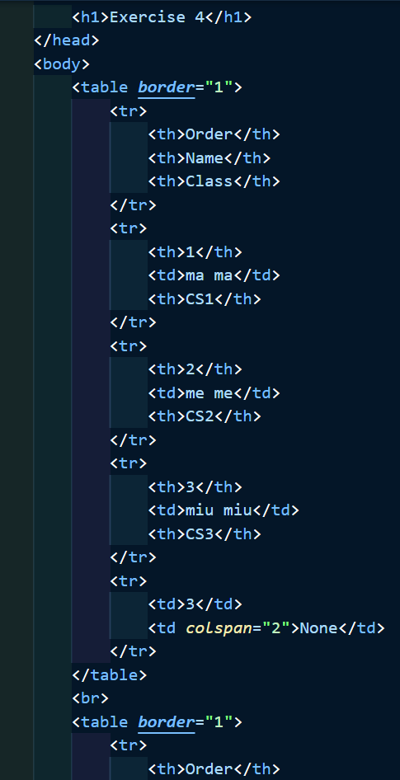

Output:

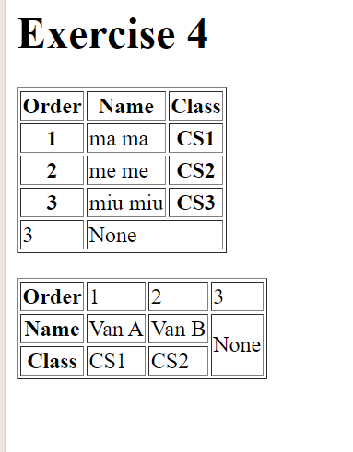

Ex5:

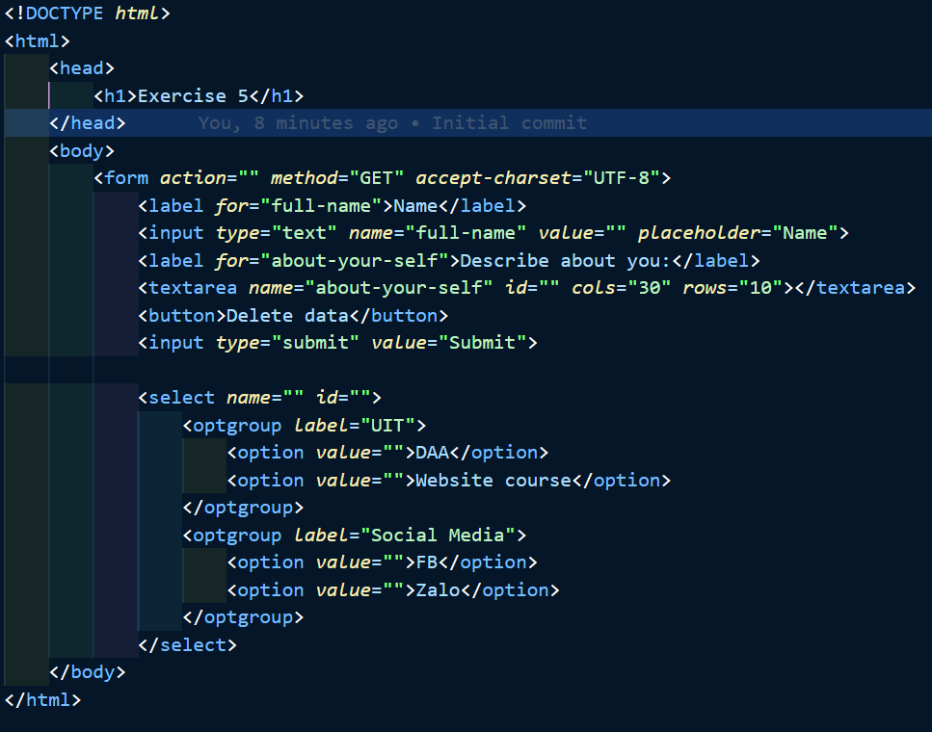

Output:

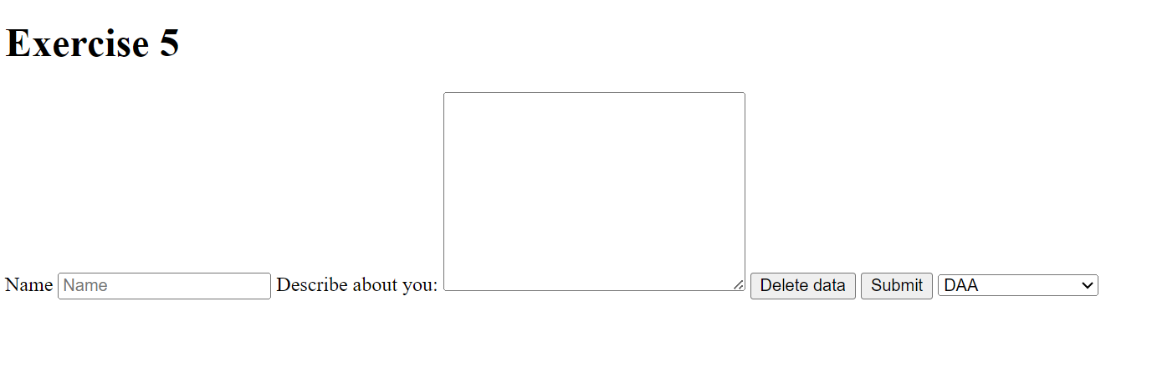

Exercise 6:

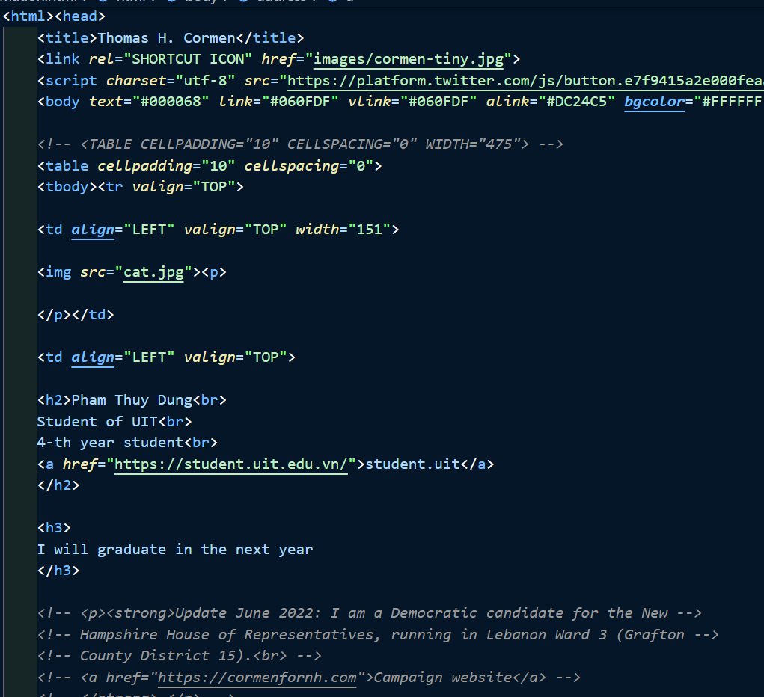

Output



Homework 1:

Output

Homework 2:

Output:

Homework 3:

Ouput:

Home work 4:

Bootstrap 4 is the fourth version of the world's most popular front-end open-source toolkit, designed for responsive, mobile-first web development. It provides developers and designers with a variety of HTML, CSS, and JavaScript components to create functional, visually appealing, and mobile-friendly web pages with ease.

Output

Link Github:

https://github.com/amenosakura/Lab1-class